Lab - Guideline

Topics
- IPv4 routing
- DHCP IPv4

- IPv4 routing

Laboratory test configuration:
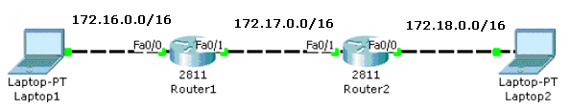

Step1: Assign static IPv4addresses to router interfaces and computers

Router>enable
Router#configure terminal
Router(config)#interface fastethernet 0/0
Router(config-if)#ip address 172.16.0.1 255.255.0.0
Router(config-if)#no shutdown
Router(config-if)#exit

Description: Add an IP address on Fa0/0subinterface

Step2: Set static routes

General syntax:
Router(config)#ip route netw_dest_address next_hop_address/interface

Router(config)#ip route 172.18.0.0 255.255.0.0 172.17.0.2

Switch #show ip route
Description: Visualize the routing table

Test the connectivity.
  - ping <target IP>
  - tracert <target IP>
- DHCP

Laboratory test configuration:

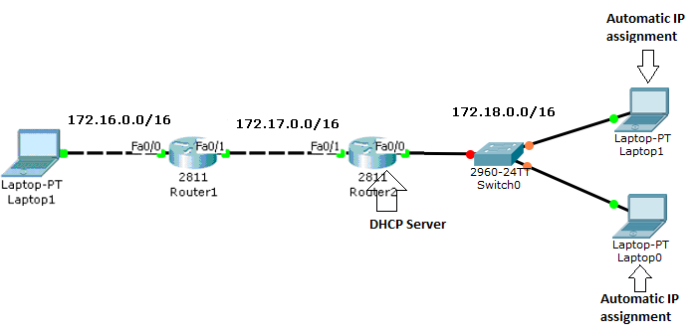
Step: Configure DHCP (commands)

Configure the pool name
Router(config)# ip dhcp pool name
Configure the addresses
Router(dhcp-config)# network network-number [mask|prefix-length]
Setting up the IP Domain Name System Servers for the Client
Router(dhcp-config)# dns-server address [address2 ...address5]
Configuring the Default Router for the Client (!the default router has to be on the same subnet as the DHCP client)
Router(dhcp-config)# default-router address
Exclude IP addresses
Router(config)#ip dhcp excluded-address start_address end_address
(Exclude IP addresses that where statically assigned)

Example:
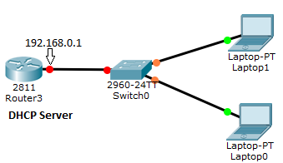
Router(config)# ip dhcp pool MY_DHCP
Router(dhcp-config)# network 192.168.0.0 255.255.255.0
Router(dhcp-config)# dns-server 8.8.8.8
Router(dhcp-config)# default-router 192.168.0.1
Router(config)#ip dhcp excluded-address 192.168.0.1 192.168.0.2

Test the connectivity.
  - check IP addresses oh hosts computers
  - ping <target IP>

